Capstone Full Report
Dominick Campbell
Dr. Kashihara
CIS480 Section 32778
11/21/2025

Hypothesis Summary
This project aimed to examine the housing market for Maricopa County and specifically residential housing prices in the area. To this end it explored 2 hypothesis throughout the project and which helped shape the project as a whole. The first hypothesis was that population density had a positive affect on housing prices, IE that houses were more expensive in places where population density was high, and the second was the median income single earners are unable to afford to buy houses in Maricopa county. To this end let us discuss the first of these two hypothesis.
The hypothesis stated that population density had a positive effect on the cost of houses in an area and this was rejected. When analyzing the population density vs median home pricing in the PowerBI we showed that pricing had no statistical significance or relevance to the cost of the homes and as such was rejected.
The second hypothesis stated that Median Single Earners are unable to afford homes in Maricopa County. This hypothesis was not rejected as evidenced by the Power BI again showing that over 80 percent of the locations in Maricopa county were unaffordable to the median single earner. This shows that some locations may have housing available but overall most areas of Maricopa County are unaffordable to the median single earner and once we analyze the median income in those supposed areas we see that even in the lower cost areas the ability to buy becomes impossible there as well.

Project Summary
There were a number of challenges in this project and I will go over a few here. This project was difficult for a number of reasons including the fact that the data set was just not available. Data for housing is held behind a number of companies all of whom want a large amount of money for the pleasure of looking at their data. This left me in the position that the only available data for the housing market is found on Zillow. I learned from this a number of things however. The first and likely most important was that data isn’t clean. Class had taught us how to work with clean data and while that was useful it meant that a number of skills that I needed weren’t skills I had going into this project. Further it also taught me how to do CSV joins and how to find and create indexes for the data to have a working data set. This then transversed over to the actual modeling.
A lot of trial and error occurred as I worked through the models and worked through the data to be able to actually have a model. In fact One of the most important findings when doing the model was that pricing data was significantly more important than every other kind of categorical data that I had collected. This shows that people will tend to hold their properties and that properties have inherent value based on the conditions of the market when they were purchased. As a result, finding information about the market and other categories became difficult and futile as the project progressed.

Real World implications
This project has a number of real world implications that can be drawn from it and I will address several of them here. The major ones I will address are the Income having little impact on pricing, Population Density and the need for more medium and high density housing. Policies that should be explored to reduce strain on the current market. Lastly the importance of reducing residential housing costs for the lay person.
The first and likely most important implication that we can take from this project is that while population density leads to a number of other factors including crime rate, it seems to have minimal impact on the housing market itself. This results in the density of housing being a minimal consideration when low density housing is obviously more desirable than medium or high density housing. This results in sprawling low density housing zoning and a number of such communities throughout the County. As a result of this Maricopa County is in a housing shortage (Milne, 2025). This often leads to more low density housing being proposed but as a result the urban sprawl will continue without having the ability to reduce meaningfully the population density issues and providing reasonable housing costs by having a meaningfully close deficit or surplus of housing units in the county.
This information leads us to the second and more important piece of information which is that income has almost no affect on the price of housing. Rent and Residential properties have skyrocketed in the last 5 years and while prices are starting to cool off some this hasn’t come to a point where the median income is able to maintain with the current markets. This results in an overinflated housing market where buyers are generally only corporations or individuals whom make significantly more than the median income. This project has looked at number of locations within the county and consistently all locations have had Income requirements for residential housing significantly higher than the mortgage requirements assuming the standard 20% down and with good credit. As a result income doesn’t matter at the moment and this will likely continue to not matter until the housing deficit becomes significantly smaller or a surplus is achieved. Furthermore, low density housing does not have the ability to meet the housing deficit described in a reasonable amount of time and this will likely result in the market stagnating for the foreseeable future.
To resolve some of these problems this project will suggest a solution that would require some level of government policy and residential planning. Increasing the amount of medium and high density housing would reduce the deficit of housing units significantly faster than low density housing will. This would allow for more units on the market, and while medium and high density housing are generally less desirable than low density housing it would provide an entry point for the current Median income classes to be able to afford and buy something. This would in turn reduce the number of buyers in the market alleviating gradually the massive market force pushing and stabilizing the costs of this market above a reasonable point to being to fade. Long term these policies would allow for a larger number of housing units as well as a larger number of low density housing communities so long as we build and supplement such communities with other medium and high density housing to ensure the number of units does not become a large deficit again.
Finally the last implication is that currently the market is saturated with houses that are not good value. With median value homes being approximately $400,000 most homes on the market are over priced compared with similar housing options in other areas of the country. This means that policy will likely have a hard time getting past special interest groups with large amounts of capital invested in Maricopa County housing. As a result of this there are a large number of ways to resolve this, but one of the fastest would be to force companies to divest from short term rentals such as AirBNB to allow for a larger number of either long term rentals in low density housing areas or for more buyers and housing units to enter the market. This would result in a decrease to the current deficit but would not completely resolve the issue. Due to this this policy change would need to be implemented in conjunction with other policies especially those attempting to increase the amount of high and medium density housing to alleviate this deficit.
In conclusion, this project was able to look at a small sample of the overall Maricopa county housing market but a number of things became apparent even within this small sample. Median income in Maricopa County cannot sustain the current residential market as homes are over priced and valued compared to the actual income of the constituents. Furthermore, the large housing deficit in the area has become a point to stabilize these over inflated house prices and reducing and eliminating this deficit should allow the market to recover to manageable levels. Lastly governmental policies will need to be implemented to ensure that medium and high density housing will be built to offset and reduce the housing deficit if we are to be able to reduce the costs and make the income match the costs in Maricopa county.

Capstone Project Selection and Proposal Document
Abstract
With the massive increase in housing in the Phoenix metro area and Maricopa County in general researching the outlook of this market especially in relation to what appears to be a stagnated labor market interests me greatly. I think that the housing market that has typically been affordable to many Arizonans has become untenable and will continue to contribute to the rise of people living with family for a longer period than in previous generations. The focus of this project is to examine and create 2 predominant models that will be paired against each other and allow the end user to examine income to house pricing as well as predicted prices for houses based on the current market with features that they desire. I feel that this has broader implications for the general audience and anyone who desires to buy or own a property at some point in the future. Furthermore, this relates well to my coursework as a significant amount of data analysis will be required as well as model preparation and model development.

Research Objective and Questions
This project aims to analyze and model the current Maricopa County housing market’s home costs based on categorical features. Further, this project intends to also collect and provide an estimated income requirement for the predicted home based on the categorical features the end user requests. This project will analyze the expected cost of the predicted home compared to the average weekly wage for Maricopa County and determine if it is feasible for someone to buy a home utilizing this median data. In addition, this project will also have a secondary model that allows one to enter current income and provides house prices and expected features for a home that would fit within the allowed income provided. Thus, leading us to the primary questions that this project will aim to address. The first of which is what percentage of homes in Maricopa County are affordable given a 20% down payment and the average weekly wage, $1510 (U.S. Bureau of Labor Statistics, 2025). The second question this project intends to answer is what features are the most valuable and what are the predominant features of homes that people working within the average wage can expect to find based upon their income. To answer these questions this project will likely have 2 models that it uses, the first a categorical regression model based upon the features of the homes within the Maricopa County, aimed at predicting the house price based upon the given features of the home. The second model will be based upon the input income, and will provide features likely to be seen on homes that can be afforded based upon information gathered from The Mortgage Reports (Higuera & Kadzielawski, 2025) and Bankrate (Vita, 2025).

Primary Data Sources and Project Scope
This project aims to utilize several different data sources with the primary data source being Policy map. Other sources of data will include Zillow and Redfin as both have a significant amount of categorical data and a breadth of other data to ensure a complete picture of the current market state. Further, this project has been influenced by several online articles listed in the references below and will reference, The Mortgage Reports, Bankrate and the U.S. Bureau of Labor Statistics in addition to the actual data sets to ensure a correct outlook and view of what is needed by the end user to purchase a home. The scope of this project is going to be limited to Maricopa County only, as further information and data while available would be outside of the area of interest for this project. Data is readily available for this project on all three of the data sources that this project intends to utilize and will be aggregated to ensure duplicate data is not affecting the performance of the model.

Feasibility and Next Steps
The project seems feasible initially, at least with only the two models though I will need to begin data preprocessing and likely review scope again once I have completed the preprocessing and data collection steps of the project. In terms of the timeline, this project is still in its infancy, and more research will be done before the project begins data preprocessing, collection, and cleaning. Next on the agenda list though is finishing research into the current markets, and beginning the data collection and processing, as well as looking into models and modeling techniques to ensure a good understanding of what kinds of models are available for such analysis and for the application of this project. Data Collection is scheduled to begin on Sunday September 21st following instructor feedback and considerations. If all goes well. Data cleaning and processing will be completed by the end of the first week of October and further timeline dates will be created as the project moves forward and a clear and detailed view of the scope and current status of the project become visible.

References
Higuera, V., & Kadzielawski, A. (2025, January 17). Mortgage Income Requirements | How to Qualify 2025. Retrieved from The Mortgage Reports: https://themortgagereports.com/85149/income-requirements-for-home-loan-guidelines
Policy Map. (2025). Policy Map. Retrieved from https://www-policymap-com.ezp.mesacc.edu/newmaps/e/mesacc
Redfin News. (n.d.). Downloadable Housing Market Data From Redfin. Retrieved from Redfin News: https://www.redfin.com/news/data-center/
U.S. Bureau of Labor Statistics. (2025, September 16). Colunty Employment and Wages in Arizona - First Quarter 2025. Retrieved from US Bureau of Labor Statistics: https://www.bls.gov/regions/west/news-release/countyemploymentandwages_arizona.htm
Vita, S. D. (2025, September 16). Income Requirements to Qualify for a mortgage. Retrieved from Bankrate.com: https://www.bankrate.com/mortgages/proving-income-to-land-a-mortgage/
Zillow. (n.d.). Housing Data. Retrieved from https://www.zillow.com/research/data/

Hypothesis and Literature Review for Capstone
Literature Review

There is a lot of literature that examines housing prices and from several different angles. Some of the literature is focused on socioeconomic factors, others focus on information for health, education, social status, crime rates and the like. All of this allows for a comprehensive view of what factors may affect property values. However, much of this information has been studied broadly with large areas generally outside of the US. This means that for the purposes of this capstone the major things that we will focus on are literature pointing towards and helping to establish the reasonings behind the current high cost of housing in Maricopa County. For the purposes of this I focused on 4 peer reviewed articles to help build the groundwork for this project.
The first article I reviewed for this was a thesis from Ryan G. Sharpe titled “The Effects of Population Density on Home Prices”. This article focuses on the population density in Sacramento California and used a dataset of over 10,000 home sales provided by the Sacramento Association of Realtors. Whilst this may not directly correlate with what is happening in Maricopa County this will provide some insights into other aspects of the country and a close neighbor to Arizona, as such inferences should be able to be drawn between the two. The first thing that this paper discusses is why density matters and the two types of density, population and residential density. With the importance of this being exemplified by “This increase often becomes a direct point of contention between neighborhood activists who may want to see their neighborhoods maintain specific design, congestion, or population characteristics and smart growth or New Urbanist advocates and planners who see increases in density as a way to provide
greater transportation, utility, and civic services to a larger population with greater economies of scale.” (Sharpe, 2018). Further summarizing this paper, it follows this by outlining residential density being a source of house prices increasing and goes on to do qualitative analysis on residential density in regard to price.
The second article I reviewed for this was “The Effect of Financial Market Factors on House Prices: An Expected Utility Three-Asset Approach” by Wang, Liu, Qiu, and Sriboonchitta. This paper, unlike others I examined, focused mostly on the mathematics and economics behind house prices and explained the math that is used to determine these prices in general. Further, this paper provided a number of variables that have helped shape the information needed for me to formulate and refine this research topic into one of reasonable scope.
The Third article I reviewed for this was Examining the Significance of Housing Enclaves in the Metropolitan United States of America by Kirby, Harlan, Larsen, Hackett, Bolin, Nelson, Rex, and Wolf. This article provides analysis on how master planning of housing in Los Vegas, Los Angeles and Phoenix and examines the total percentage of owners and renters broken down into 3 major categories: White, Black and Hispanic. Further, it examines the differences between what it calls Census Categories, ie. Total US households, Households in Enclaves, and Households in gated enclaves. This paper focuses on the impacts of these Master Planned developments, and on HOA’s in particular, with an examination of the social and political barriers that arise as a result of the construction of such enclaves and gated enclaves.
The final article that this project will reference is “Why Phoenix – of All Places – Has The Fastest Growing Home Prices in the U.S.” by Luscombe. This article looks at the housing market during the Covid-19 pandemic and what that did to not only the ability to buy residential properties, but also what happened to the rental market as a result. This paper then goes over interview information provided by a buyer, a realtor, a business professor, an industry analyst and a researcher on their thoughts on the different reasons for the market increases. With each of these different perspectives relating to different reasons as to why they feel the market is spiking “In the last year alone, the cost of the median house in the area has risen by a third. Over the course of two years, it's up 57%, yanking rental prices with it.” (Luscombe, 2022). This article further emphasizes that multiple market factors may be contributing to our housing market in general, but all of them emphasizing that they didn’t feel like the market was going to come back down or cool off any time soon.

Hypothesis
With the reading and research I have done into the current market, this project will focus on 2 hypotheses. These hypotheses will aim to answer a couple of major research questions. First, how does population density and residential density impact residential home value? Second, are current salaries in Maricopa County able to support single income residential home purchases?
Null Hypothesis 1: Population and Residential Density contributes strongly to residential home value (2-tailed test)
Alternate Hypothesis 1: Population and Residential Density have no correlation to residential home value.
Model: Lasso regression with dependent variable being home value, and independent variables being residential density, population density, crime, and property acreage.
Null Hypothesis 2: Single income median earners have insufficient income to purchase residential properties in Maricopa County. (1-tailed test)
Alternate Hypothesis 2: Single income median earners have sufficient income to purchase residential properties.
Model: Linear regression with income requirements as dependent variable and categorical features such as bedrooms, acreage, crime rate, population density, zip, city, and residential density are independent variables.

Bibliography
Luscombe, B. (2022). Why Phoenix--of All Places--Has the Fastest Growing Home Prices in the U.S. Time.Com, 23.

Kirby, A., Harlan, S., Larsen, L., Hackett, E., Bolin, B., Nelson, A., Rex, T., & Wolf, S. (2006). Examining the Significance of Housing Enclaves in the Metropolitan United States of America. Housing, Theory & Society, 23(1), 19–33. https://doi-org.ezp.mesacc.edu/10.1080/14036090500435995

Wang, Y., Liu, J., Qiu, Z., & Sriboonchitta, S. (2022). The Effect of Financial Market Factors on House Prices: An Expected Utility Three-Asset Approach. Axioms (2075-1680), 11(4), 145. https://doi-org.ezp.mesacc.edu/10.3390/axioms11040145

Sharpe, R. G. (2018). THE EFFECTS OF POPULATION DENSITY ON HOME PRICES. Sacramento: California State University.

Data Visualization and Analysis

Hypothesis Overview and Connection
This project aimed to explore the relationship between the median single earner and the ability to purchase a home with regards to current house pricing. Further, it also aimed to explore and show what kind of home they might be able to purchase. In addition to this, this project also evaluated the relationship between population density and home pricing by examining the affect of population density on the price of a home and if it was of any real importance. As such, the project aimed to examine the following two hypotheses, both of which being a 1 tailed test. Null Hypothesis 1: Population density contributes strongly to residential home value in Maricopa County. Alternate Hypothesis 1: Population Density has no statistical significance on residential home pricing in Maricopa County. Null Hypothesis 2: Single income median earners have insufficient income to purchase residential homes in Maricopa County. Alternate Hypothesis 2: Single income median earners have sufficient income to purchase residential homes in Maricopa County.
With this in mind, we can discuss the features that were available for collection as well as what charts this project will aim to provide the end user for viewing and understanding the conclusions of the data. Features of the data in this project included Zip Code, City, Home Type, Population Density, Median Home pricing data by month, and Income per Capita. While other categorical features of the homes would have been useful and would have improved the data quality of the dataset as a whole, such data was not publicly available in a way that would have been useable for this project. As a result, these are the features that were utilized to evaluate the above hypothesis. Charts for this project will include the following type with intentions to visualize information regarding the hypothesis as well as evaluation of the machine learning models created for this project. Let us first start with the machine learning model chart:
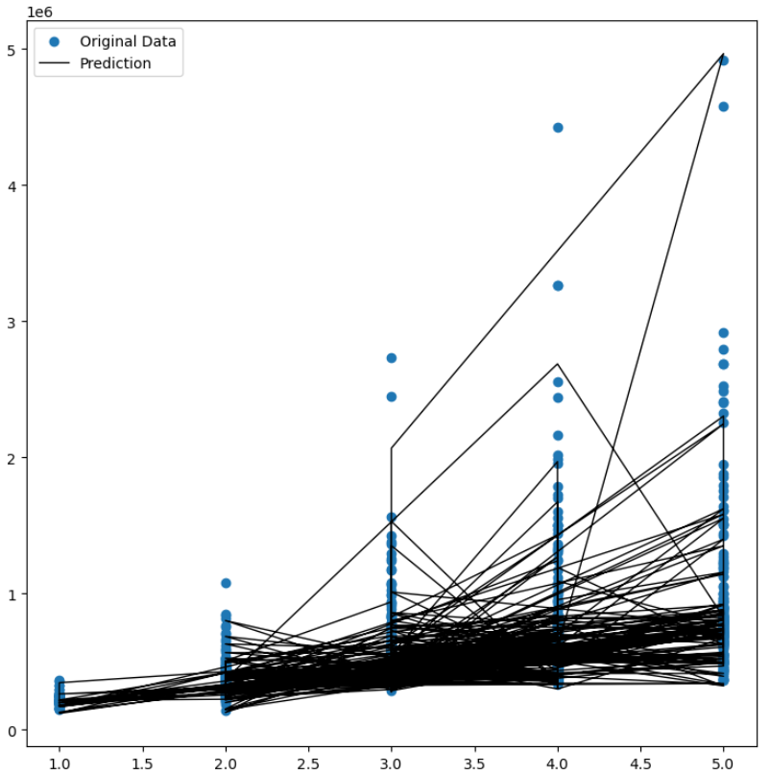
This was a prediction graph created from the Lasso regression model attempting to predict pricing based on the original data vs the predicted data. R2 value for this model was 0.98, showing that the data for the this is almost positively overfit. However, other categorical factors did not have enough of a representation to create a model with statistical significance, with the maximum R2 score being ~0.22 with all other features beside pricing data from 01/31/2020 included and a graph of the model for this is below.
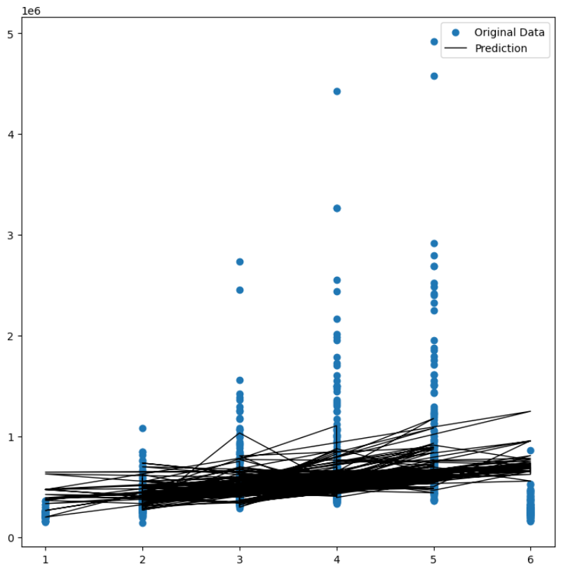
Further analysis with only population density data reveals an R2 value of 0.0142, showing a statistically insignificant value for the model, as shown by the prediction graph below:
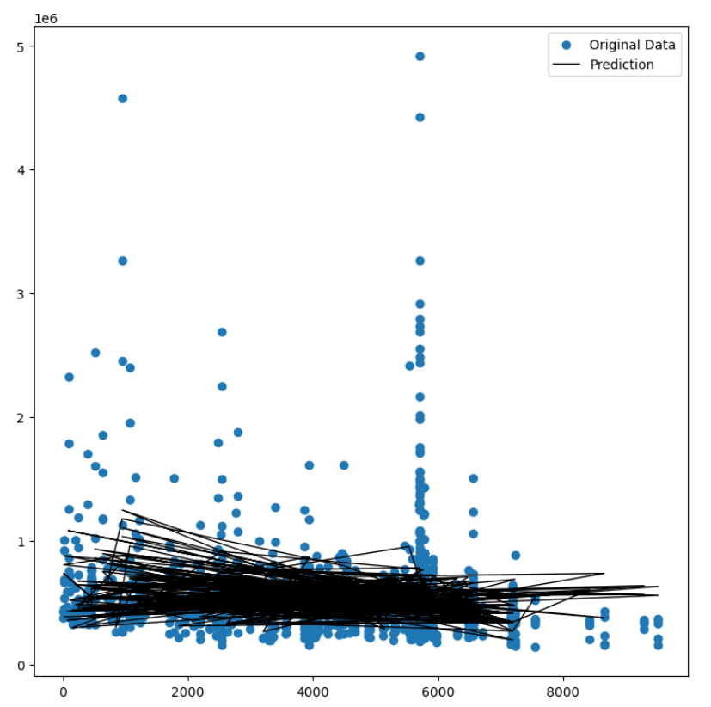
Further to answer the second question, this project aimed to have a decision tree categorical model for categorizing the Maricopa County market by housing price data represented as Monthly Mortgage Payments by the different types of residences. The chart below shows the categorical model’s representation of this:
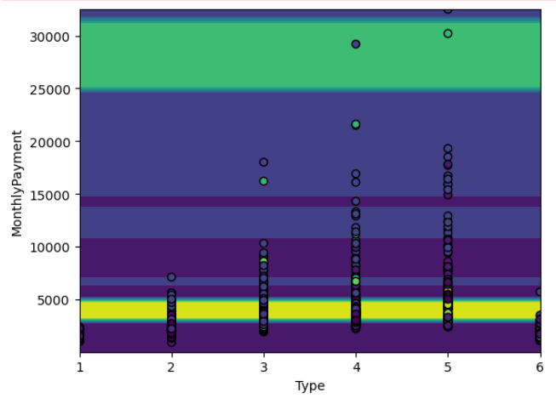
The first chart this project aims to utilize will be a pie graph showing the count of values within the dataset that made up homes based on the slicer settings and user input filtered by city and monthly payment:
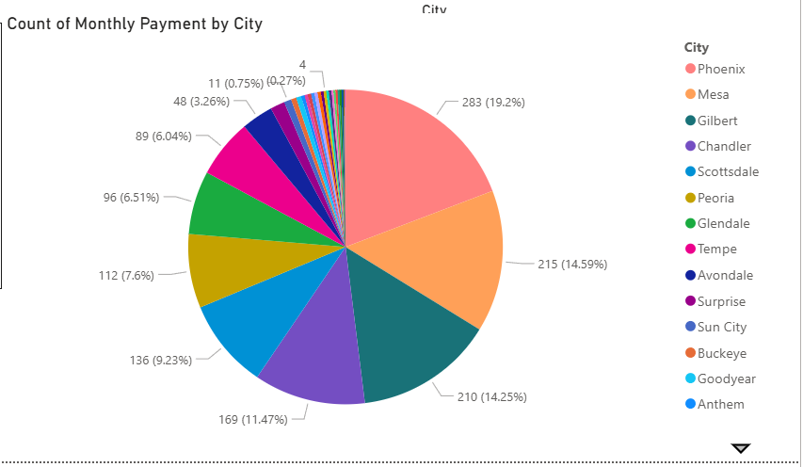
The second chart intended for this project is a bar chart that breaks down the monthly payments by the type of residence:
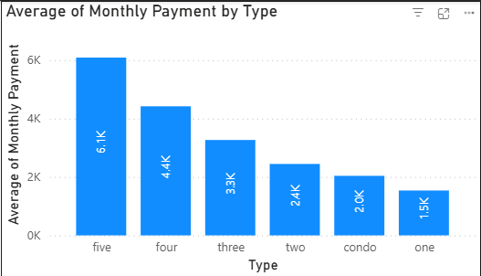
The third chart aims to explore the information related to the average price of homes by per capita income and is filtered and broken down by the city information. This allows us to examine the affect of per capita income on the housing market as well as see where outliers exist that may be worth looking into.
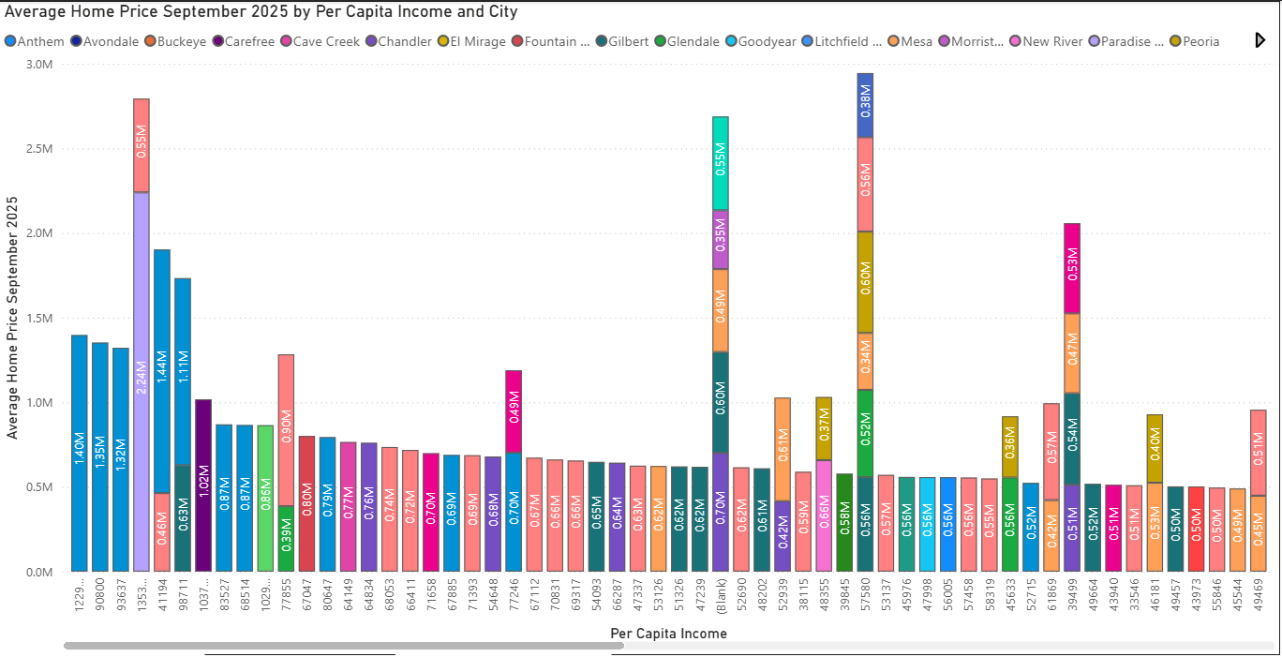
The next chart is a population density chart showing population density compared to house pricing for Maricopa County. This chart aims to show the above mentioned population density mismatch found when doing the machine learning model creation and answer directly one of the hypotheses. The following chart is an example of what this will look like though it still needs some refinement
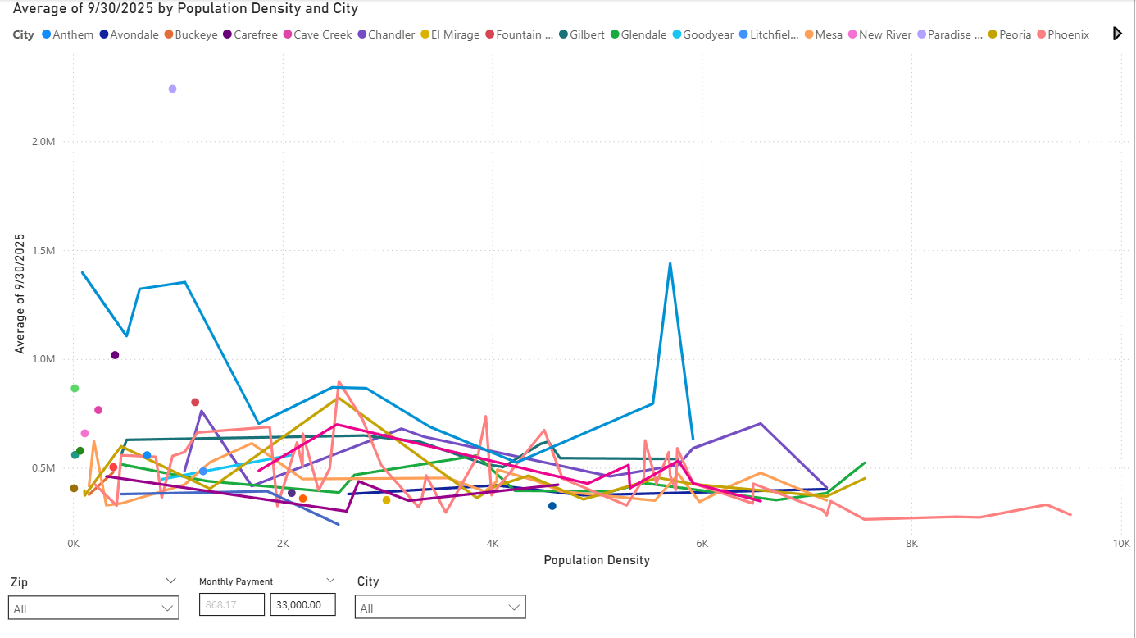
The final group of charts that this project will aim to present will be a side by side set of bar charts showing the average per capita income maximum monthly payment amount as defined by no more than 50% of take-home income to be utilized for a mortgage payment. In essence, average per capita income divided by 12 (now monthly income), divided by 2 to become the maximum allowable mortgage payment determined by zip code. Next to a bar chart showing the average monthly payment determined by the mortgage calculation with a credit score between 700-760 and an interest rate from 10/23/2025, by zip code. Both charts will have a city legend to ensure that any zip code traversing multiple cities will show the information about both.
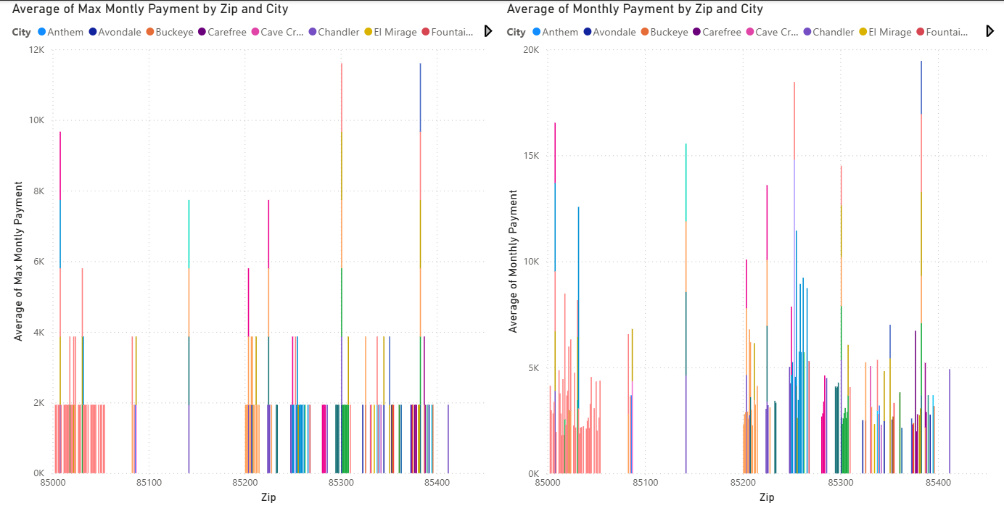
Lastly, the report aims to have 3 slicers that are synced across all report pages to ensure ease of use and readability. The slicers will be made up of 3 different features. The first feature being zip codes, the second being monthly payment, and the last being city. This allows for analysis of more granular levels of data, allowing the end user to see data more clearly as broader views of the charts are mostly unusable, but become important as the data becomes more granular.
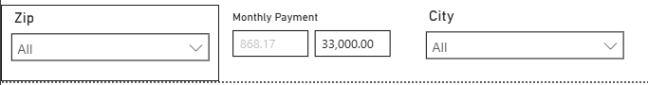

Capstone Data Collection and Modeling
Data Collection
Data collection for any project regardless of intent should be thorough and should encompass the breadth of the topic that is to be explored. As a result of this, I will use policy map and the US Census Bureau as data sources for this project. This project intends to look at analyze, model and predict not only housing prices but also categorical features of homes within income brackets input by the users. To this extent Policy map provides a robust and varied group of data for this project. US Census data allows us to model population density, income, city information, as well as look at other factors such as crime, all of which may affect the pricing of properties. Furthermore, this project is intended to analyze and model this data within Maricopa County. These sources are intended to be used due to their extensive breadth of related information and high-quality data. This should result in the project having a better chance to accurately model the real estate market for Maricopa County effectively. As well as allowing for models that can be used by end users with a degree of certainty that lower-level data sources such as Zillow or Redfin may not be able to provide. Further this model intends to look at several categorical features within the data including but not limited to: Acreage, Sq Footage, City, Crime rate, Bedrooms, and Bathrooms. Other Data that may be collected for this project will likely include Median Household and Median Single Earner income. This project will also reference sites such as Zillow, Home Mortgage Disclosure Act, as well as things such as the Federal Reserve. This is to ensure that the model for median household and single earner model will be able to accurately capture the categorical features of homes within budget based on real world banking standards.
In addition to the above, data cleaning for this project will rely on two major things, getting rid of missing values by imputing the median and also by ensuring that only homes on the market within the last five years, 2020 – 2025 will be included in the data set so as not to skew the current market trend with historical data from before the housing boom during covid.

Modeling
Ensuring that there is an accurate model that is not overfit to the test data will be important to this project and it will utilize several means to ensure this is avoided. Firstly, a regression model will be used and trained on a test-train-split function with the current data we have while evaluating the categorical variables provided to ensure that only the most impactful negatively and positively remain. In addition, the model will be checked with mean squared error (MSE) and R² Scores to ensure that the output of the model maintains statistical significance. If further training is required other forms of modeling will be passed through and the model will be trained using random forests or decision trees to ensure that it accurately predicts the current real estate market. This, however, only covers the first of the two models that this project aims to create. The second model this aims to work through will aim to collect categorical data from a user including their current debt to income ratio, income, and desired city to live in, and will output a list of home features and a price where they can expect to be able to afford based on mortgage lending and current market conditions. This model will be categorical in nature but will likely utilize many of the same modeling techniques and much of the same information as the model for house pricing information. This should ensure that at the end of this the two models are able to predict both house prices based on categorical features: as well as provide the end-user information about what residence they can afford based on their current financial conditions.
Further the reason that the two styles of model have been chosen is to ensure that the data matches the model capabilities. Where in the first model we are intending to predict a continuous house price based upon the categorical features entered the second model intends to provide categorical features to the users themselves. As a result of this, regression models are aptly able to predict such home prices and information and excel at such tasks. This leads me to intend to utilize either a Lasso Regression or a linear regression model to answer the associated questions with this. In contrast to this, categorical models allow for the grouping of different groups and outputting the expected conditions for a group based upon an input. This is much better suited to answering the second question as we can map the most impactful categorical features of a home to a heat map with the income required / mortgage payment information into groups and use thresholds of income and debt to income as well as city information to take mean home categorical features and output them to the user. Allowing us to provide user benefits by giving them an expectation of what features they should expect, compared to blindly guessing whether or not a home is within their price range and whether they are overpaying for residential features compared to other homes within the market.

Bibliography
Milne, Z. (2025, September 18). Housing Affordability In Arizona. Retrieved from Common Sense Institute Arizona: https://www.commonsenseinstituteus.org/arizona/research/housing-and-our-community/housing-affordability-in-arizona-quarter-2-2025-update

